CONSUMER LEASE APPLICATION

 | DEALERSHIP INFORMATION
Dealership
Contact |  |  | Phone Number
Yr | Make |  | Model
MSRP |  | Term |  | Payment

APPLICANT

APPLICANT NAME ss # DATE OF BIRTH _ HOME PHONE
CELL PHONE _

EMAIL ADDRESS --------------

EMPLOYMENT
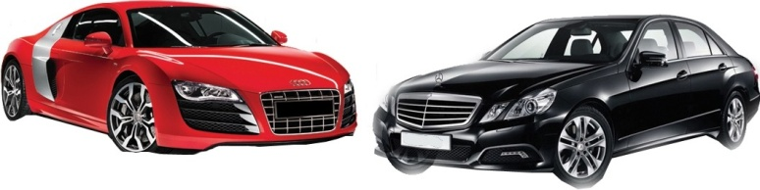
BIG APPLE AUTO GROUP LLC

17555 Atlantic Blvd ,Sunny Isles Beach, Florida 33160.646-623-6750 Nationwide Delivery “WHOLESALE/FLEET PRICING FOR LEASING/CASH/FINANCING/NEW/USED ALL MAKES/MODELS”

STREET ADDRESS
CITY --------- STATE -- ZIP _ OWN RENT LIVE WITH FAMILY
YEARS AT RESIDENCE ------------ MONTHLY RENT/MORTGAGE _

NAME OF EMPLOYER _

ADDRESS ---------------------
PHONE #

Co-APPLICANT

TITLE ANNUAL INCOME _ YRS AT CURRENT EMPLOYER

APPLICANT NAME

ss # DATE OF BIRTH _
STREET ADDRESS

CITY --------- STATE -- ZIP _

HOME PHONE
OWN RENT
LIVE WITH FAMILY

CELL PHONE _ EMAIL ADDRESS -------------
YEARS AT RESIDENCE ------------

MONTHLY RENT/MORTGAGE _ NAME OF EMPLOYER _

NAME OF EMPLOYER _
ADDRESS _

PHONE #
TITLE

ANNUAL INCOME _
YRS AT CURRENT EMPLOYER _

The undersigned applies for the Lease/Finance in this application. Everything stated in this application is correct. Big Apple Auto Group may retain
application whether or not the Lease/Finance is approved. Big Apple Auto Group and it's authorized Affiliates are authorized to check my credit for the purposes of determining my credit worthiness at the time of my application or thereafter in connection with the same transaction or extension of credit and for the further purpose of reviewing the account taking collection activity on the account and skip tracing. Big apple auto group and it's Authorized Affiliates are authorized to provide history information to others about my credit standing and your credit experience with me including but not limited to credit bureaus, other companies outside collection agencies and outside attorneys.
Applicant Co-Applicant
Authorized Signature Authorized Signature _
Print Name -
__________
Date______

Print Name --------------------------------------------------- Date ------------------

CONSUMER A PPLICATION BIG APPLE AUTO GROUP LLC TPC-App B

